Event-driven cloud-native applications

The event-driven architecture must reach across into your application platform. Developers build applications that interact with events, and the applications are event-driven. That is, they both produce and consume events by using the event backbone. In this context, think of the event backbone as being part of the microservices mesh, providing the publish-and-subscribe communication between microservices, and enabling the support of loosely coupled event-driven microservices.
Microservices are the application architecture of choice on cloud-native platforms. As businesses become event-driven, the event-driven pattern needs to extend into your microservices applications. Your microservices are still making REST calls to well-known microservices. However, they must respond to and send out events. In event-driven terms, they need to be both event producers and consumers to enforce strong decoupling.

The event backbone: Publish-and-subscribe communication and data sharing for microservices
With the adoption of microservices, the focus on synchronous communication between services is increasing. Service mesh packages such as Istio help you manage communication, service discovery, load balancing, and visibility in this synchronous communication environment.
With event-driven microservices, the communication point becomes the publish-and-subscribe layer of the event backbone. By adopting an event-based approach for intercommunication between microservices, the microservices applications are naturally responsive (event-driven). This approach enhances the loose coupling nature of microservices because it decouples producers and consumers. It also enables the sharing of data across microservices through the event log.
These event-style characteristics are increasingly important considerations when you develop microservices applications. In practical terms, microservices applications are a combination of synchronous API-driven and asynchronous event-driven communication styles. From the implementation view, a set of established patterns is used, such as Database per Service, Event Sourcing, Command Query Responsibility Segregation (CQRS), and Saga.
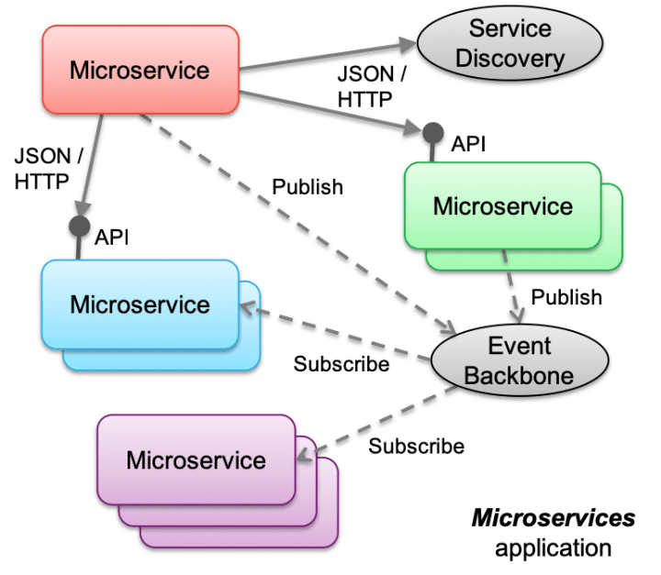

Event-driven applications with containers
While the serverless approach with IBM® Cloud Functions provides a simplified event-based programming model, most microservices applications are developed for and deployed to a container-based cloud-native stack. Within the cloud-native landscape, Kubernetes is the standard platform for container orchestration and the base for the container platform in the event-driven architecture.
The event backbone is the publish-and-subscribe communication provider and event log for shared data for the microservices. In this context, microservices are developed as direct consumers and producers of events on the backbone by using topics. The extra work in this environment is in managing consumer instances to respond to the demand of the event stream. You must determine how many consumer microservice instances need to be running to keep pace with or always be available to run the microservice in response to an arriving event.

Event-driven microservice patterns
Adopting publish and subscribe as a microservice communication backbone involves at least these patterns:
- Decompose by subdomain: Event-driven microservices are still microservices, so you need to find them. The use of domain-driven subdomains is a good approach to identify and classify business function, and therefore, microservices. With the event-storming method, aggregates help to find those subdomains of responsibility.
- Database per service: This pattern enforces that each service persists data privately and is accessible only through its API.
- Saga pattern: Microservices publish events when something happens in the scope of their control, such as an update in the business entities that they're responsible for. A microservice that is interested in other business entities subscribes to those events and can update its own states and business entities when the microservice receives such events. Business entity keys need to be unique and immutable.
- Event sourcing: This pattern persists the states of a business entity as a sequence of state-changing events.
- CQRS helps to separate queries from commands and to address queries with cross-microservice boundaries.
Additional considerations:
- Business transactions span services and are more of a series of steps. Each step is supported by a microservice that is responsible to update its own entities, leading to the eventual consistency of the data.
- The event backbone must guarantee that events are delivered at least once. The microservices are responsible to manage their offset from the stream source and deal with inconsistency by detecting duplicate events.
- At the microservice level, updating data and emitting events needs to be an atomic operation to avoid inconsistency if the service fails after the update to the data source and before the event is emitted. This operation can be done by adding an eventTable to the microservice data source and having an event publisher that reads this table regularly and changes the state of the event when published. Another solution is to have a database transaction log reader or miner that is responsible to publish events on a new row in the log.
- One other approach to avoid the two-phase commit and inconsistency is to use an Event Store or Event Sourcing pattern to track what is done on the business entity with enough data to rebuild the data. Events are becoming facts that describe state changes to the business entity.

